ARRAY IN JAVA

INITIALIZATION OF ARRAY..

Int a[];

Int a[];

a = new int[3]

int []a = new int[3];

int []a = new int[]{1,2,3,4};

WAP To initialize and print a array?

import java.util.\*;

class array {

public static void main(String[] args)

{

int size;

Scanner sc = new Scanner(System.in);

System.out.println("Enter the size");

size =sc.nextInt();

int a[]=new int[size];

for(int i=0;i<size;i++)

{

a[i]=i;

System.out.print(a[i]+" ");}

}}

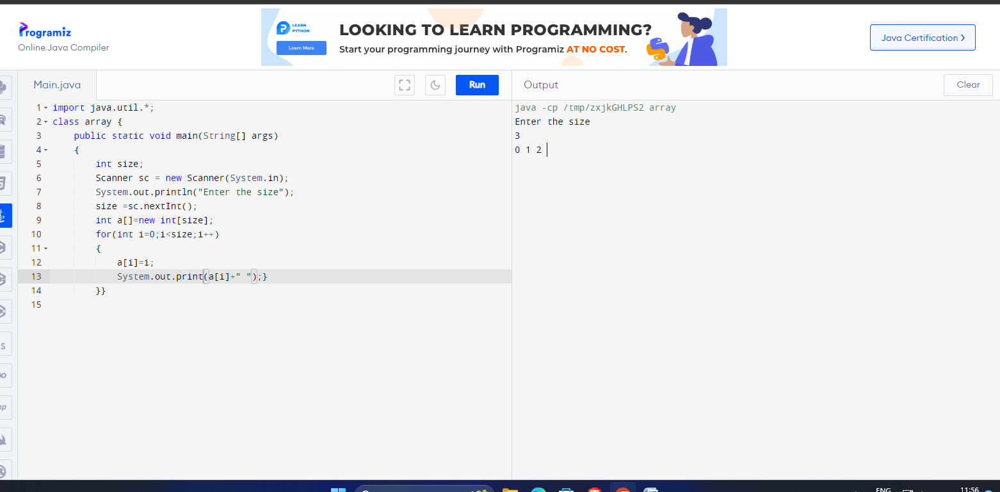

WAP To demonstrate for each loop using array?

class array {

public static void main(String[] args)

{

int []age ={1,2,3};

System.out.print(age.length );

for(int a:age){

System.out.print(a);

}

}}

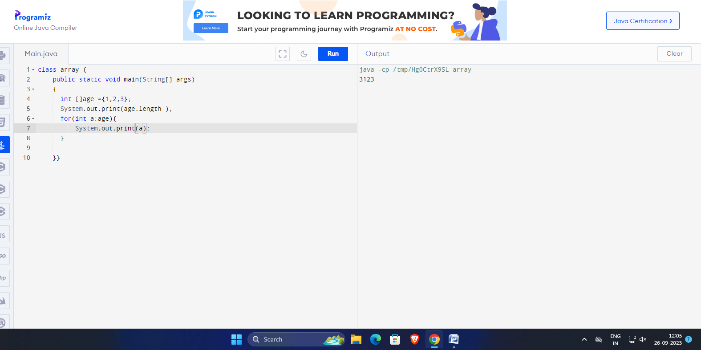

WAP To create an integer array calculate the sum and average of this array using for each loop?

class array {

public static void main(String[] args)

{

int []num ={1,2,3,4,5,6,9,10};

int sum=0;

double avg=0;

System.out.println(num.length);

for(int a:num){

sum=sum+a;}

System.out.println(sum);

avg=sum/num.length;

System.out.println(avg);

}}

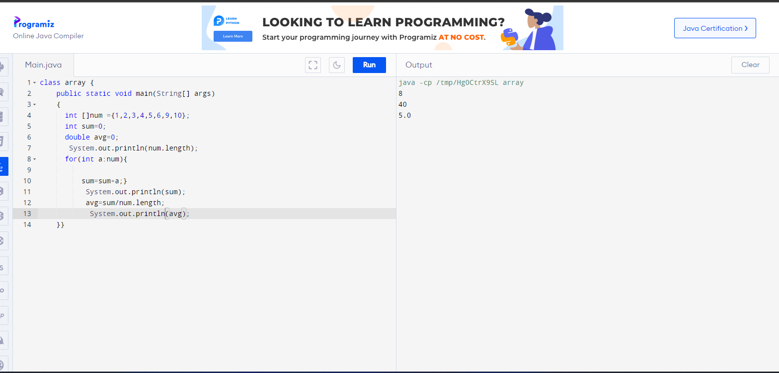

DEMONSTRATION OF INBUILT ARRAY CLASS AND TWO STRING METHOD AND METHOD OVERLOADING?

import java.util.Arrays;

public class atul {

public static void main(String[] args)

{

int []a = {2000,1978,1980,2002};

String[]s = {"joy","ram","shyam"};

System.out.println("Integer array is "+Arrays.toString(a)) ;

// Function overloading

System.out.println("String array is"+ Arrays.toString(s));

}}

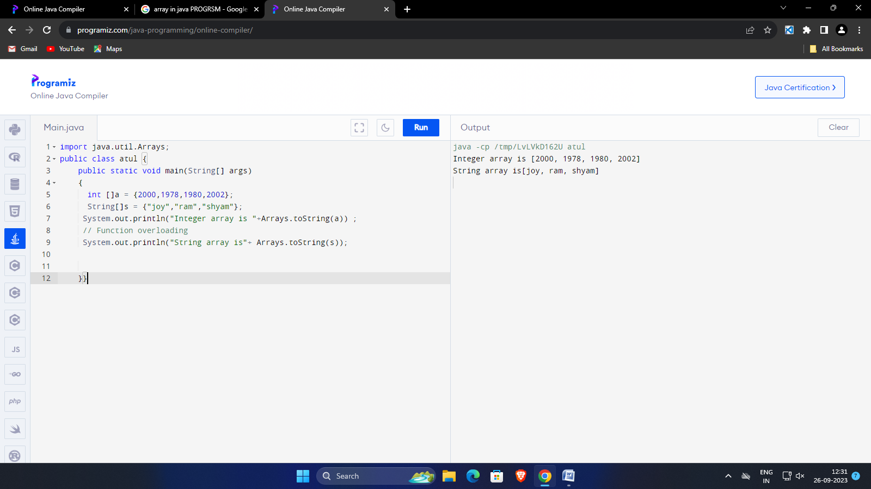

WAP TO FIND MAX AND MIN VALUE FROM SORTED ARRAY?

import java.util.Arrays;

public class atul {

public static void main(String[] args)

{

int []a = {2000,1978,1980,2002};

String[]s = {"joy","ram","shyam"};

System.out.println("Integer array is "+Arrays.toString(a)) ;

// Function overloading

System.out.println("max is"+a[3]);

System.out.println("min is"+a[0]);

}}

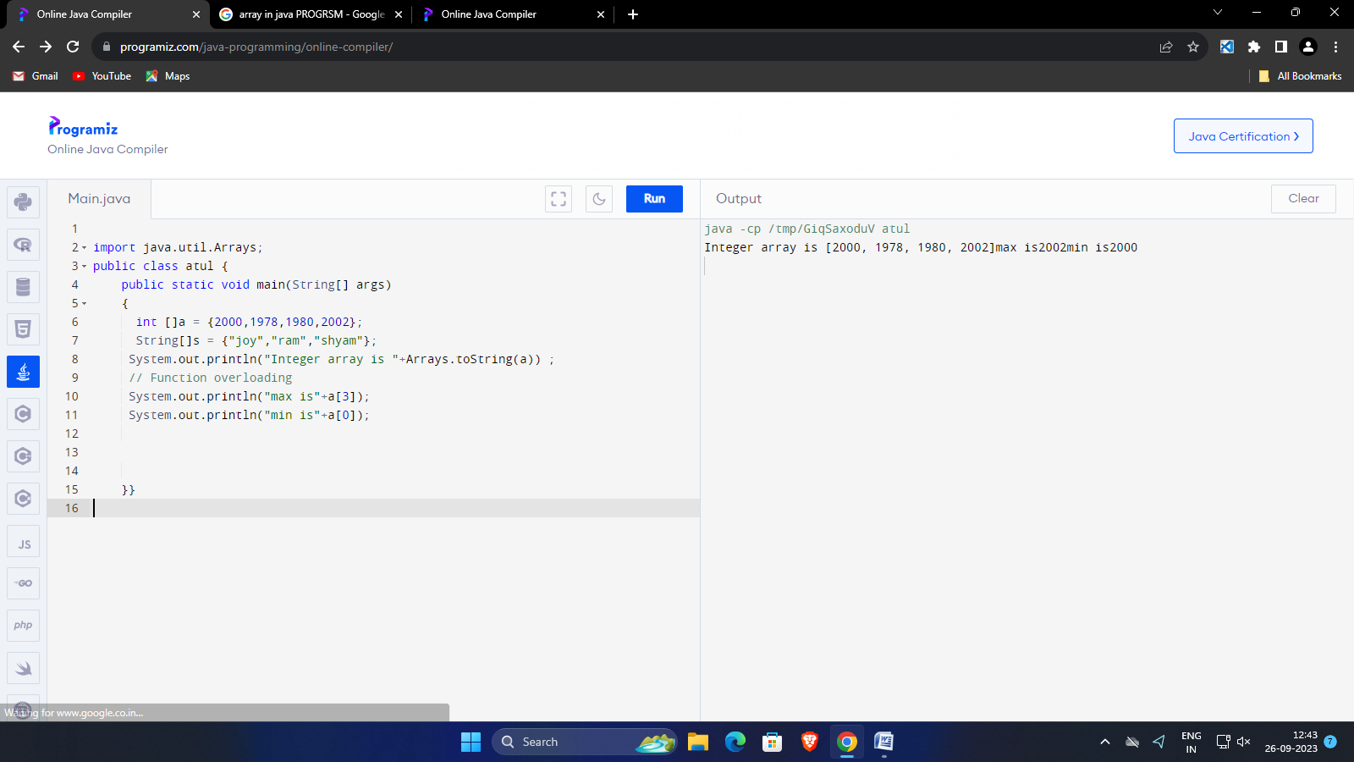

CREATE AN INTEGER ARRAY OF POSITIVE INTEGER AND COUNT THE NUMBER OF EVEN AND ODD NUMBER OF ARRAY?

import java.util.Arrays;

public class atul {

public static void main(String[] args)

{

int []a = {1,2,3,4,5,6};

System.out.println("Integer array is "+Arrays.toString(a)) ;

{

int even=0.odd=0;

if(a%2==0)

count++

System.out.println("even value is "+ a)

;

}

if(a%2!=0)

count++

System.out.println("odd value is "+ a)

;

}}